**Plantains and Caribbean Chicken Satay**

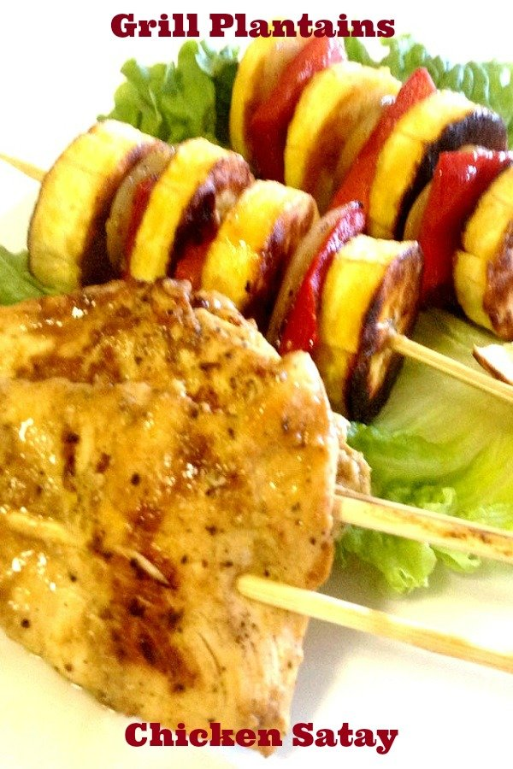

**INGREDIENTS**

**Chicken**

1 1/2 pounds skinless, boneless chicken breasts

1 lime, juiced

20 or more wooden skewers

Green leaf lettuce for garnish

**Plantains**

2 ripe yellow plantains

1 red bell pepper

1 yellow onion

4 Skewers

**Marinade For Chicken:**

1 teaspoon paprika

1 teaspoon onion powder

1 teaspoon kosher salt

1 teaspoon black pepper

1 cup plain greek yogurt

4 cloves garlic, minced

4 leaves of chado beni, finely chopped or cilantro

1/2 scotch bonnet pepper, finely chopped

1 teaspoon freshly grated ginger (about a knuckle)

2 tablespoon curry powder

2 tablespoon freshly squeezed orange juice

2 tablespoon pineapple juice (optional)

2 tablespoon of Olive Oil, for your griddle

**Peanut Mango Sauce**

1 ripe mango peeled, pitted and chopped

1 1/2 tablespoons lime zest

2 large clove garlic, peeled

1/2 scotch bonnet pepper, chopped

2 tablespoons dark brown sugar, optional

2 limes, juiced

1 cup hot water divided

1/4 cup low-sodium soy sauce

1 cup smooth peanut butter

**METHOD**

**Chicken**

1. Butterfly and cut into strips
2. Place in a clean bowl or zip lock bag
3. Add lime juice and toss to combine, set aside.

**Chicken Marinade**

1. Combine paprika, onion powder. Kosher salt, black pepper, yogurt, minced garlic, grated ginger, orange juice, chado beni, scotch bonnet pepper, pineapple juice and curry powder.
2. Add to the chicken pieces, gently toss until well coated, refrigerate for at least two hours, or overnight if you have the time
3. Thread the chicken pieces onto the skewers working the skewer in and out of the chicken.

**Plantains**

1. Peel and cut plantains into rounds

**The Actual Cooking**

1. Heat a griddle to about 375 degrees, brush with a small amount of olive oil, place plantains and grill until golden brown, about 1 - 2 minutes per side, do the same if you are using peppers and onions.
2. Thread onto skewers by adding plantains, pepper and onion, repeat until you have about 5 - 6 pieces of plantains on one skewer. Keep covered until ready to eat!

**Chicken**

1. Clean your griddle and reheat, brush with small amount of olive oil.
2. Grill the chicken satays for 2-to 3 minutes on each side, until nicely seared on both sides.
3. Place in an aluminium foil pan, keep covered.
4. Heat oven to 500 degrees.
5. Place covered aluminium foil pan with chicken in hot oven for about 10 - 12 minutes before serving.
6. Serve on a bed of lettuce with a nice and spicy peanut and mango dipping sauce.

**Direction for Mango Peanut Sauce**

1. In a blender or food processor blend mango, lime zest, garlic scotch bonnet pepper, lime juice and 1/2 cup water.
2. Add peanut butter, soy sauce and remaining hot water, continue blending until very smooth.
3. If the sauce is too thick, you can add some additional water to thin it out.
4. Pour the sauce into a nice sauce bowl and garnish with cilantro. Serve with Caribbean style chicken satay